Birthday Simulation

This project implements a simulation of the Birthday, a probability theory problem that demonstrates how the probability of shared birthdays in a group increases surprisingly quickly as the group size grows.

Project Overview

The simulation consists of two main classes:
- Person: Generates random birthdays for individuals
- BirthdaySimulation: Runs the simulation with specified parameters and calculates probabilities

Components

Person Class
- Generates random birthdays in MM/DD format
- Handles different month lengths appropriately (28, 30, or 31 days)
- Uses Java's Random class for randomization

BirthdaySimulation Class
- Takes two parameters:
- numberOfPeople: Size of the group to simulate
- numberOfRuns: Number of times to run the simulation
- Calculates the probability of shared birthdays in the group
- Returns the probability as a double value between 0 and 1

Usage Example

// Create a simulation with 23 people and 1000 runs
BirthdaySimulation simulation = new BirthdaySimulation(23, 1000);
double probability = simulation.runSimulation();
System.out.println("Probability of shared birthdays: " + probability);
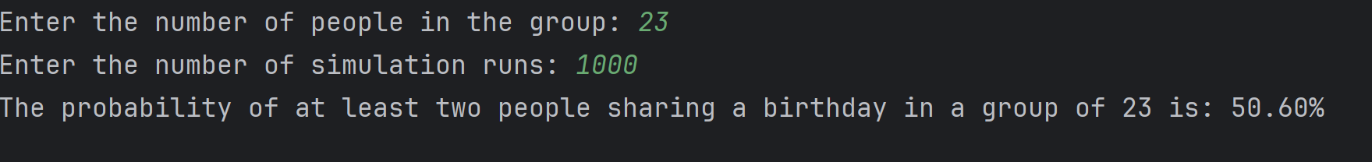

## The Birthday

The Birthday states that in a group of 23 people, there is a 50.60% chance that at least two people share the same birthday. This might seem faulty because:
1. There are 365 possible birthdays
2. With 23 people, it might seem unlikely to have a match
3. However, the number of possible pairs grows quadratically with group size

Details

The simulation uses an array to store birthdays
Birthday comparison is done using string matching
The simulation runs multiple times to get an accurate probability
All months are treated as having either 28, 30, or 31 days (February is simplified to 28 days)

